# 

Augmented intelligence in Retail

University of Leeds

Author: Rayaan Rizwan Noor

Date: 23rd November

Word count: 1022

Table of Contents

Introduction 2

Methodology 3

What is Augmented Intelligence in the retail industry? 3

Legal, Ethical, Social and Professional issues 3

Evidence based projections for the short term (1-2 years) 5

Evidence based projections for the Medium term (5 years): 6

Evidence based projection for the long term (10 or more years) 6

Conclusion 6

# Summary

The report discusses the advancements of Augmented Intelligence (AUI) in the Retail Industry over the next 10 years. Augmented intelligence is focused on the human-Artificial Intelligence (AI) partnership to increase cognitive performance. And the retail industry consists of businesses that sell directly to customers. AUI is already being implemented in the value chain in particular, the Data Mining subset is being used to efficiently and strategically make business decisions. The goal for AI is to mimic the ways humans learn and think but because of the unpredictable human nature, AI would not replace humans for at least the next 5 years. But then, AI in the next 10 years will be intelligent enough where it can take over operations in the value chain independent of human judgement and supervision. In conclusion, the retail industry is developing fast into the digital world and is now essential for a business to take advantage of Big data analytics paired with Human judgement in order to compete in the industry. Therefore, and investment should be made.

# Introduction

This report aims to discuss the advancements of Augmented Intelligence (AUI) in retail over the next 10 years. I will explore how AUI has been implemented into the retail industry and the impact it has had. By the end of this report, the reader will have a clear idea of whether to invest in this upcoming research-led innovation or not. In simple terms, AUI is a mix of Artificial Intelligence (AI), Machine Learning (ML) and human judgement. With the fast-paced digital retail world, millions of data are being generated every second but with no value, this is where AUI comes into play. It allows humans to make timely, smart and strategic decisions in enterprise. AUI is an upcoming innovation expected to change the way industries work and is vital to see how we can adapt to this change.

# Methodology

This report looks at the development of AUI and its impact on the retail industry. To gain a better insight into the applications of AUI, I explored research papers, scholarly publications and technological websites. To further understand the sources, I categorized key terms, mind mapped ideas and noted key points.

# What is Augmented Intelligence in the retail industry?

AUI is the mix of any AI and human rational, it aims to improve cognitive performance and decision making. In particular, the subset of AUI that impacts the retail industry is data mining. It discovers and extracts patterns and trends in big data. The retail industry consists of companies that directly sell to customers. It augments human judgement with high powered AI models to reshape business functions. It uses its ML and Natural Language Processing (NLP) capabilities to swift through data and give insights (e.g consumer shopping trends) making for more valuable and timely decisions. Unlike AI, it intends to support and not to replace.

# Legal, Ethical, Social and Professional issues

When developing technology that handles sensitive data about an individual it is vital to make sure it complies with laws and ethical factors. It is essential to create protocols on where the data is got from and how it is used. Illegal forms of data mining could be that the data is used to discriminate racially or sexually against people. In terms of legal, there are two laws currently present which are: 1) Federal agency data mining reporting act of 2007, 2) Prescription Data Mining Legislation (UKEssays, 2018)[1]. The professional issue could arise, due to AI speed, day to day tasks and decision making will fall in the hands of the AI, leading to a lack of motivation in the employees thus lacking creativity. It is essential to find the optimal balance between technology and humans to have the best results.

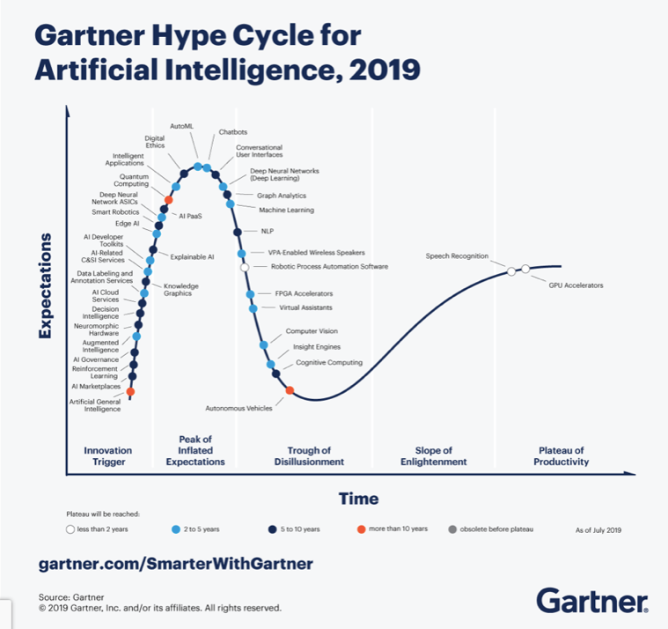

Figure Gartner Hype cycle (Gartner, 2019)[2]

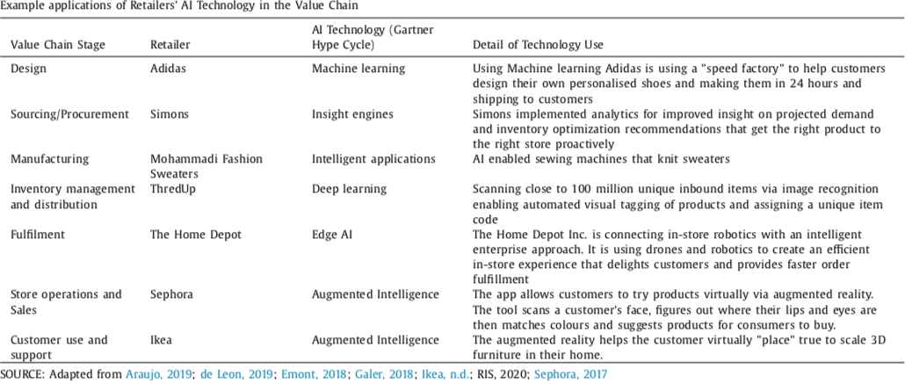

Table 1 AI in retail (Australian Marketing Journal, 2020)

# 

# Evidence-based projections for the short term (1-2 years)

In recent years, businesses that can serve customers with greater efficiency have been at the forefront of the industry while traditional retailers are facing threats. AI has led to the disruption of the value chain [3]in businesses, the four dimensions are: 1) knowledge and insight management, 2) Inventory Management, 3) Operations and Optimization, 4) Customer Engagement (Australian Marketing Journal, 2020)[4]. It will mainly be used in marketing and targeting customers with greater precision. Table 1 shows the diverse nature of AI where it could be implemented anywhere in the value chain. In the short term, AUI is said to take the “jobs to be done approach” (Harvard Business Review, 2016)[5]. When creating a product, it is not the product itself you look at, it is the functionality you look at. This approach was then adopted by businesses seen in figure 2 for the applications of AI in the value chain.

# Evidence-based projections for the Medium-term (5 years):

In reference to figure 1, AUI is set to plateau in 5 years while AI is set to plateau in 10 years. Although AI may develop to be more autonomous a major setback is its decision-making ability. Figure 1 shows that decision intelligence is to peak in 10 years meaning it would still take human judgement to make the right ethical decisions. As for data mining, it is already almost at its peak as it gives businesses insights into pricing forecasts, stock market patterns etcetera. But an upcoming technology that will most likely be used by businesses in 5 years is augmented reality which uses data and the surrounding environment to create a computer-generated event. This would create an efficient and engaging in-store experience.

# Evidence-based projection for the long term (10 or more years)

The growth of the retail industry and AI is unprecedented. In 10 years, time AI would most likely be automated without the need for human guidance. “Integrating channels and the power of big data are not distinctive factors anymore but rather are prerequisites of competitiveness” (Dhruv Grewal, 2017)[6]. Traditional retailers would not survive in the data-driven industry, it will become a need for AI to stay afloat. With technologies such as Deep Learning and NLP at their peak, they will extinguish the need for Human judgement in AI leading to a more autonomous value chain and an end to AUI. This would result in a loss of in-store and jobs that require a minimal amount of skill, leading to savings in expenditure but could reduce business-customer communication.

# Conclusion

AUI is a mix of machine models and human judgement. In conclusion, AUI is a must make investment due to the rapid changes in the industry. Many companies are already taking advantage of AUI in different departments of their organization. Statistics show that most businesses that have implemented Augmented intelligence had a five percent or more [7]revenue growth. AUI would still be a very prominent technology in five years but in ten years when AI starts to develop it may not need human intervening, but the investment is mainly in the AI so even as deep learning starts to advance AI the investment will not be lost and will continue to benefit the business.

# References

Grewal, D. 2017. Future of Retailing. Journal of Retailing. 97(3)

Gartner. 2019. [Online]. [Accessed 20 November 2021]. Available from: <https://www.gartner.com/smarterwithgartner/top-trends-on-the-gartner-hype-cycle-for-artificial-intelligence-2019>

Havard Business Review. 2016. [Online]. [Accessed 21 November 2021]. Available from: <https://hbr.org/2016/09/know-your-customers-jobs-to-be-done>

Begley, S. and Fox, R. 2018. How analytics and digital will drive next-generation retail merchandising. *McKinsey & Company*. [Online]. [Accessed 22 November 2021]. Available from: <https://www.mckinsey.com/industries/retail/our-insights/how-analytics-and-digital-will-drive-next-generation-retail-merchandising>.

K. Oosthuizen, E. Botha and J. Robertson et al., Artificial intelligence in retail: The AI-enabled value chain, Australasian Marketing Journal, https://doi.org/10.1016/j.ausmj.2020.07.007

Lui, A. and Lamb, G.W. 2018. Artificial intelligence and augmented intelligence collaboration: regaining trust and confidence in the financial sector. *Information & Communications Technology Law*. **27**(3).

Anon n.d. What is Augmented Intelligence? - IEEE Digital Reality. *digitalreality.ieee.org*. [Online]. [Accessed 22 November 2021]. Available from: <https://digitalreality.ieee.org/publications/what-is-augmented-intelligence>.

Anon n.d. The future of decision-making: augmented intelligence. *Genpact*. [Online]. [Accessed 25 November 2021]. Available from: <https://www.genpact.com/insight/point-of-view/the-future-of-decision-making-augmented-intelligence?gclid=Cj0KCQiAys2MBhDOARIsAFf1D1diDXwgXGxNiEYJA6OGLc2tulyzqz1_X_GhOOrTYBGurVOHb5Obix8aAqphEALw_wcB>.

Cath, C. 2018. Governing artificial intelligence: ethical, legal and technical opportunities and challenges. *Philosophical Transactions of the Royal Society A: Mathematical, Physical and Engineering Sciences*. **376**(2133).

Anon n.d. Gartner Reveals Five Major Trends Shaping the Evolution of Analytics and Business Intelligence. *Gartner*. [Online]. [Accessed 26 November 2021]. Available from: https://www.gartner.com/en/newsroom/press-releases/2019-10-02-gartner-reveals-five-major-trends-shaping-the-evolution.

‌

Zheng, N., Liu, Z., Ren, P., Ma, Y., Chen, S., Yu, S., Xue, J., Chen, B. and Wang, F. 2017. Hybrid-augmented intelligence: collaboration and cognition. *Frontiers of Information Technology & Electronic Engineering*. **18**(2).

‌

‌

‌

‌

‌

‌

1. https://www.ukessays.com/essays/information-technology/data-mining-the-privacy-and-legal-issues-information-technology-essay.php
2. https://www.gartner.com/smarterwithgartner/top-trends-on-the-gartner-hype-cycle-for-artificial-intelligence-2019
3. The processes that a business undergoes that provides value to their product or service
4. https://www.gartner.com/smarterwithgartner/top-trends-on-the-gartner-hype-cycle-for-artificial-intelligence-2019
5. https://hbr.org/2016/09/know-your-customers-jobs-to-be-done
6. https://www.sciencedirect.com/science/article/pii/S0022435916300872
7. <https://www.statista.com/statistics/1083482/worldwide-ai-revenue-increase/>